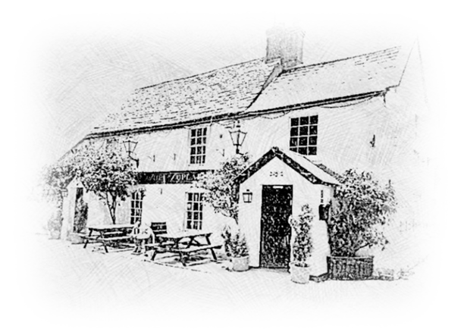
THE POPLARS
Country Pub and Dinning

... Mix and Mach ...
One from each section 7.50
Breaded Chicken Filets
Grilled Chicken
Fish Goujons
Honey Glazed Ham

Crusty Bread
Plain Chips
Rosemary Chips
New Potatoes

Leaf Salad
Peas
Baked Beans
Gravy
Seasonal Vegetables
Fresh Carrots and Cucumber
Fried egg

Sunday Only
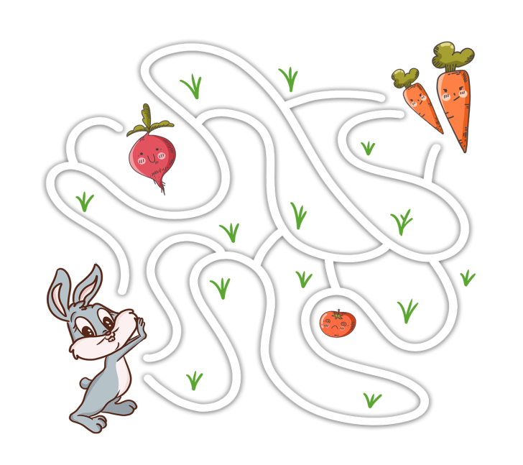
Mini Sunday Roast 9.50

Puddings :

Mini Crumble 2.50
Mini Brownie 2.50

Ice creams :
Chocolate, Strawberry, Vanilla
1 scoop 1.50, 2 scoops 2.50

